How to complete a workshop application ?

Step by Step:
Instructions for online Participants System of International Training Workshops
Dear Applicants/Participants:
Before you try to start the following steps, please MAKE SURE You've,
(1) decided to participate a Training Workshop of the ITP program in your working or research area
(2). contacted with the coordinator of your selected workshop to request the admission brochure.
Now, Start the application process!

Step.1 Start your Internet Browser.(Browsers with IE kernel are recommend)
Step.2 Enter address URL：https://mostitp.cistc.gov.cn/student_login.aspx
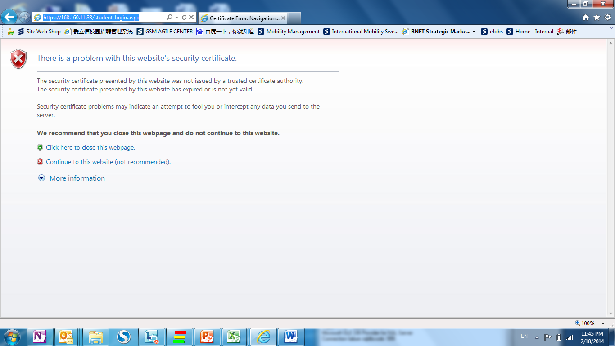
Step.3 Click “Continue to this website (not recommended)”in the reminder page.

Step.4 Select “Apply for new workshop in year 201X””.Click“go”in the Homepage.
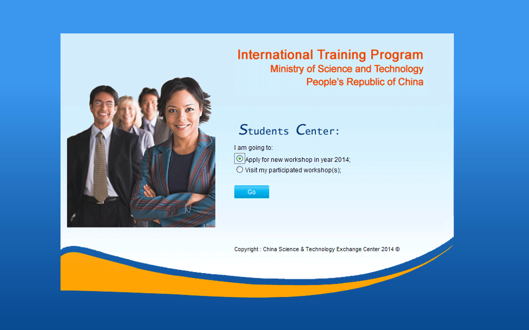
Step.5 Complete Application Step1. Choose your“Current Nationality”,input “Surname”，“Given Name”and “Passport Number”. And click “next”. Note: All the information should be completely consistent with your passport information. E.g.
Surname: TEST, Given Name: TEST1, Passport Number :G11111111
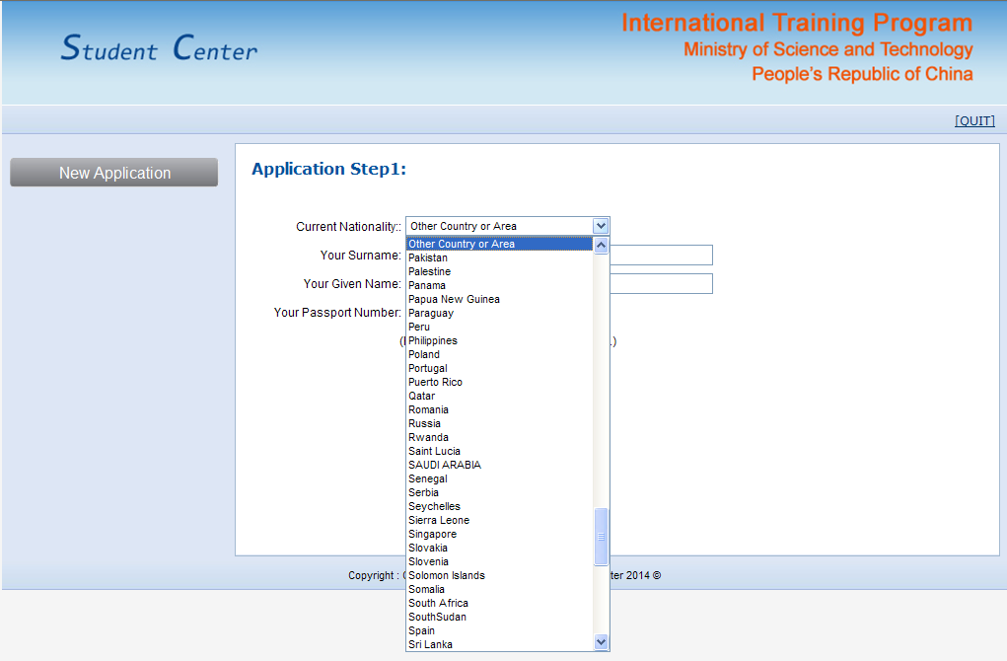
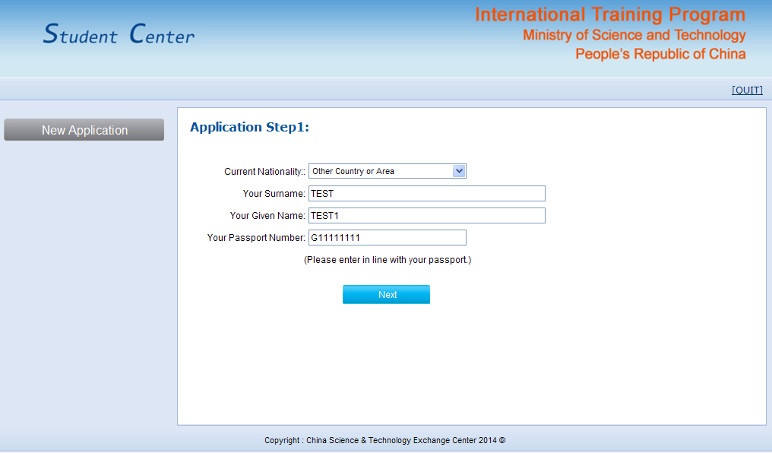
Step.6 Complete Application Step2. Please fill in all the blanks based on your personal situation.
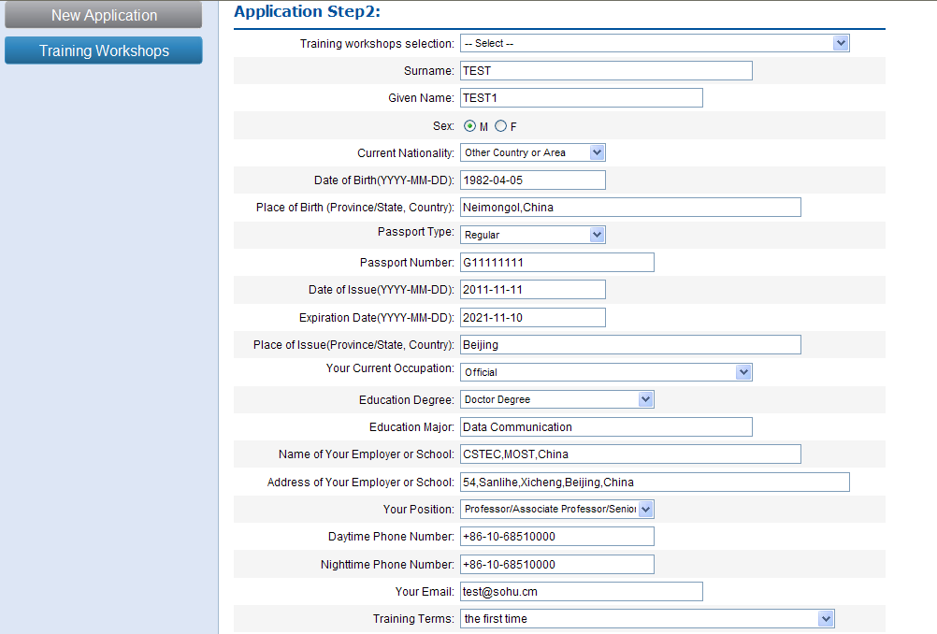
Select your the corresponding workshop you contacted in the “Training workshops selection” area. NOTE：Each applicant is only allowed to participate in one training workshop within one year.
When complete all the blanks, please click“Browse..”and upload your photo.
Photo size: small 2-inch (48mm × 33mm) face color photo, and picture size should be less than 200kB.（only accept .jpg format.）
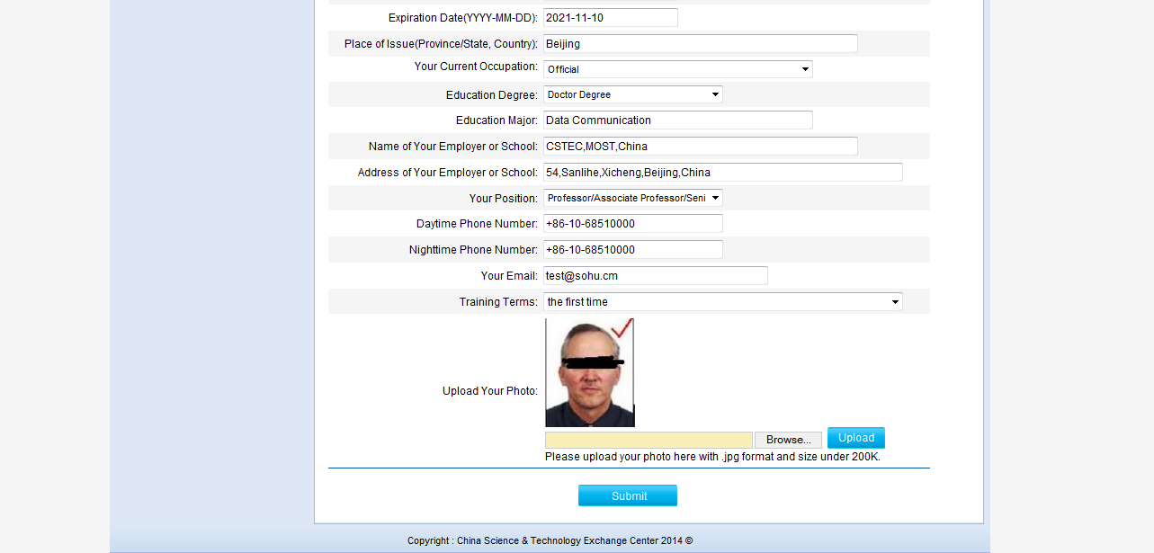
If complete the operation above, Click “submit ”, and you will see “You application has been submit successfully.”on the page STEP3.
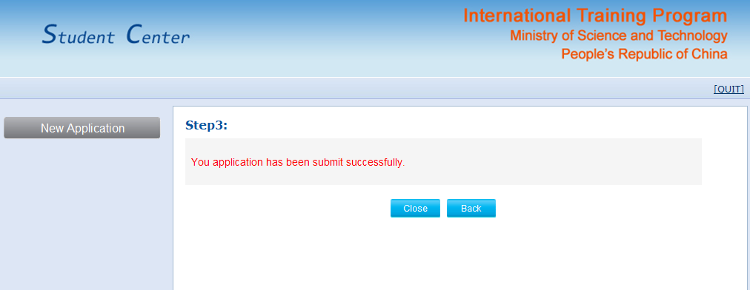
Congratulations!
You have completed the application and registration process. To guarantee the security of your private information, please be sure to click Close or QUIT to exit.
We recommend that when you complete these steps, it is better for you to contact with the corresponding Chinese organizers again via E-mail to reminder them that you have completed the application.
PLEASE Log into this website regularly, check your application status.

How to check your application status ?
Step.1 Start your Internet Browser.(Browsers with IE kernel are recommend)
Step.2 Enter address URL：https://mostitp.cistc.gov.cn/student_login.aspx
Step.3 Click “Continue to this website (not recommended)”in the reminder page.

Step.4 Select “Apply for new workshop in year 201X””. Click“go”in the Homepage.

Step.5 Choose your“Current Nationality”,input “Surname”，“Given Name”and “Passport Number”. And click “next”. Note: All the information should be the same with your registration information. E.g. Surname: TEST, Given Name: TEST1, Passport Number : G11111111
Step.6
If finding the following tips:“Your application has not been processed yet” , which means your application has not been processed yet.
If finding the following tips:“Your application is processing. Please wait for result.” , which means your application has been processed .At this time, please pay attention to check your E-mail box, organizers may contact with you to ask for additional information.
If finding the following tips:“Your application has not been accepted. You can apply for other workshop.”, which means your application has been rejected .You can try to apply for other workshop.
If finding the following tips:“Congratulations! Your application has been accepted. You can update your contact information below:”, which means your application has been accepted .You will receive the confirm letter by E-mail or Fax within a few days.
How to do the evaluation of your training workshop?
Step.1 Start your Internet Browser.(Browsers with IE kernel are recommend)
Step.2 Enter address URL：https://168.160.11.33/student_login.aspx
Step.3 Click “Continue to this website (not recommended)”in the reminder page.

Step.4 Select “Visit my participated workshop(s)””.Click“go”in the Homepage.
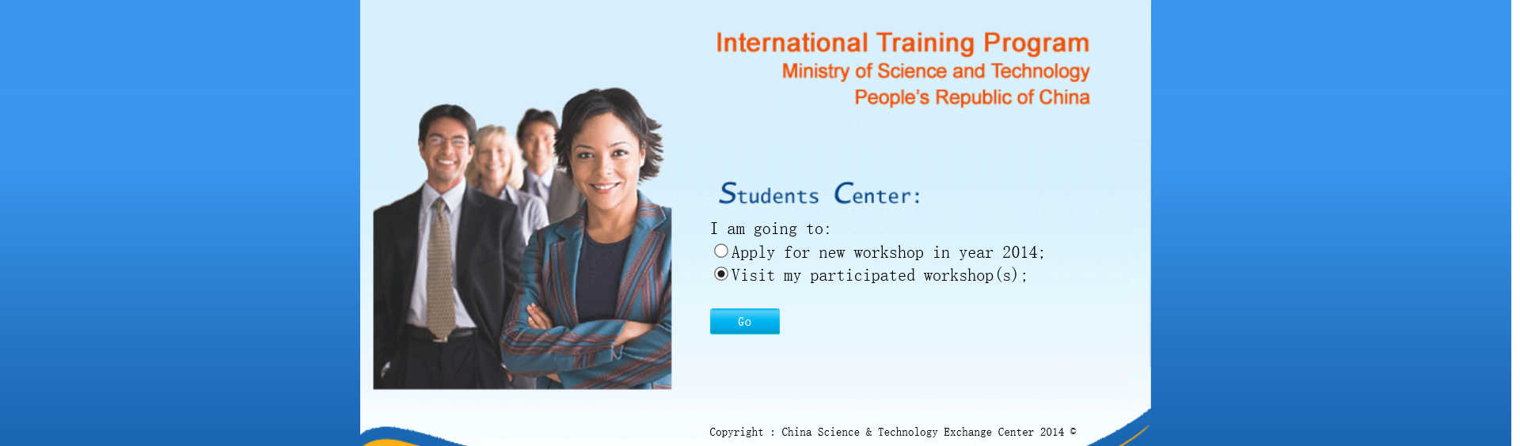
Step.5 Choose your“Training Year”, “Workshop”，and“Your Study No.”and input your “Passport Number”. And click “next”. Note:your can get Your Study No. From the contact person of your workshop organizers.
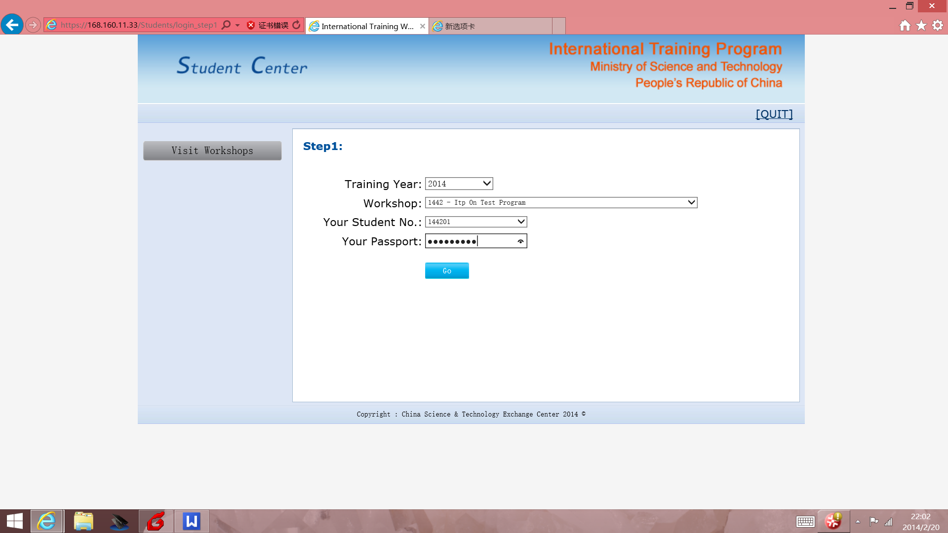
Step.6 Please complete the QUESTIONNAIRE and Click “submit ”.
Note: The evaluation was back to back. Please fill in the QUESTIONNAIRE according to your true feelings.After clicking submit, either workshop organizers or the governing bodies are not able to match your comments with your real name.

After returning to your home, you can also visit this website at any time to check the information about the other participants, update your personal information to keep in touch with others. (Select “Visit my participated workshop(s)”Choose your“Training Year”, “Workshop”，and“Your Study No.”and input your “Passport Number”. And click “next”.)
