TUBITAK JOINT APPLICATION SYSTEM TUTORIAL
Welcome to TUBITAK Joint Application and Evaluation System (Ortak Başvuru ve Değerlendirme Sistemi) Introduction
This system has been established to create a “literally” joint application and evaluation experience for researchers, reviewers and institutional experts from all over the world.
The possibilities of the System:
- Application via the same electronic system. 2 coordinators, 1 system, 1 proposal (the submission of same documents.)
- Access to the system both by Turkish Coordinator, Counterpart Coordinator, Turkish Institution Expert (TUBITAK Expert) and Counterpart Institution Expert.
- Both Turkish Coordinator and Counterpart Coordinator can access to the same application and each party can make any changes in it.
- Both Turkish Institution Expert and Counterpart Institution Expert can access every application in a call and inspect the uploaded proposal documents.

STEP BY STEP THE JOINT APPLICATION SYSTEM

Step 1. Registration to TUBITAK’s Researcher Information System-ARBIS (Araştırmacı Bilgi Sistemi)
In order to log in to Joint Application System, both Coordinators and Institutional experts need to have an ARBIS account via https://arbis.tubitak.gov.tr/home.jsf
The necessary steps to register ARBIS are shown below:

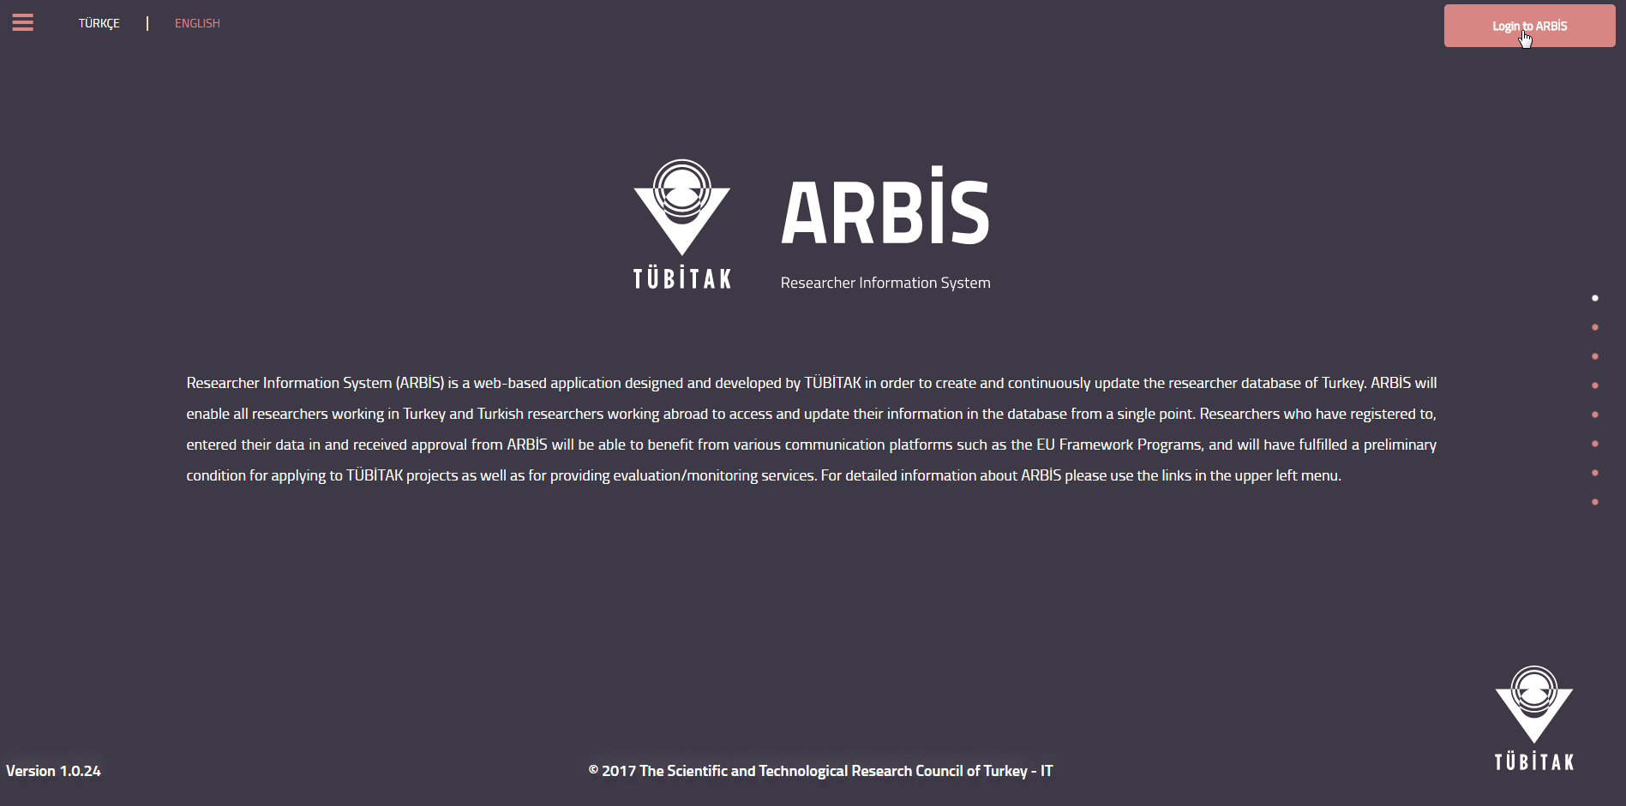
On the ARBIS welcome screen, please click on the button “Login to ARBIS”
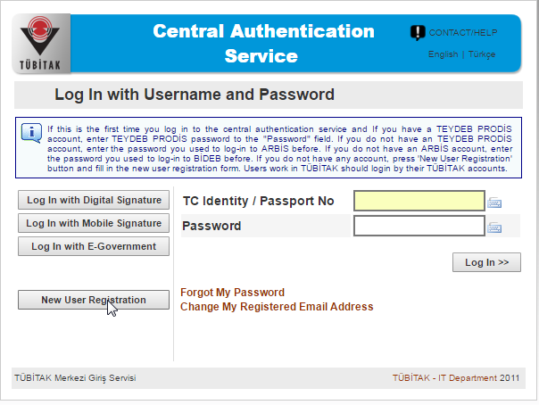
Please click on “New User Registration” to start your registration.
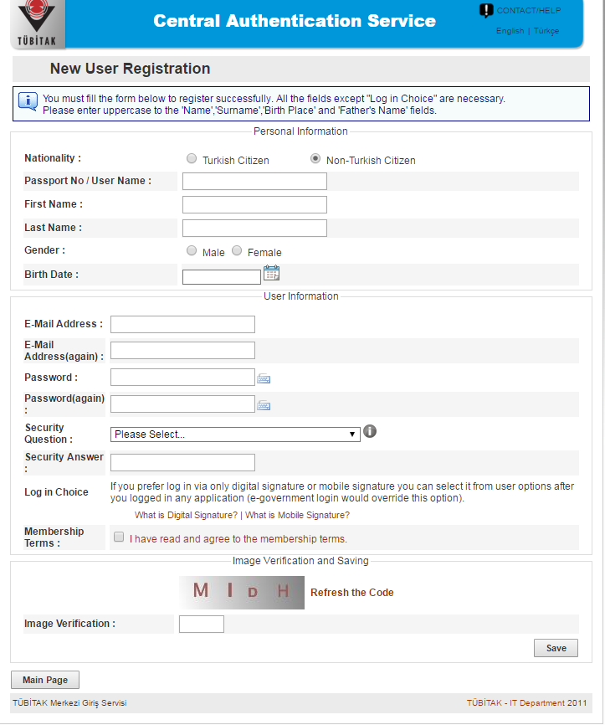
After fulfilling the registration form, you may log in to ARBIS with your “passport number” and/or “user name” and “password”.
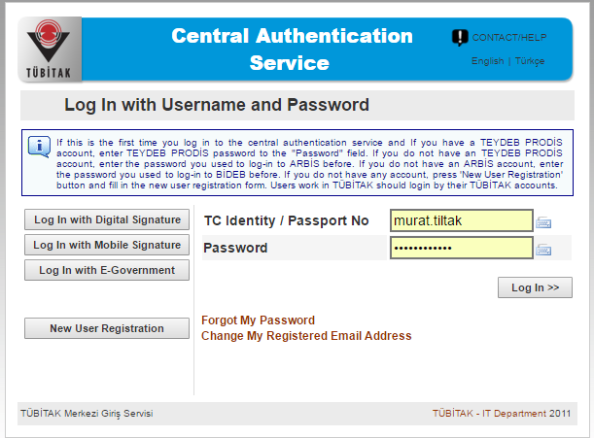
Log in to ARBIS.
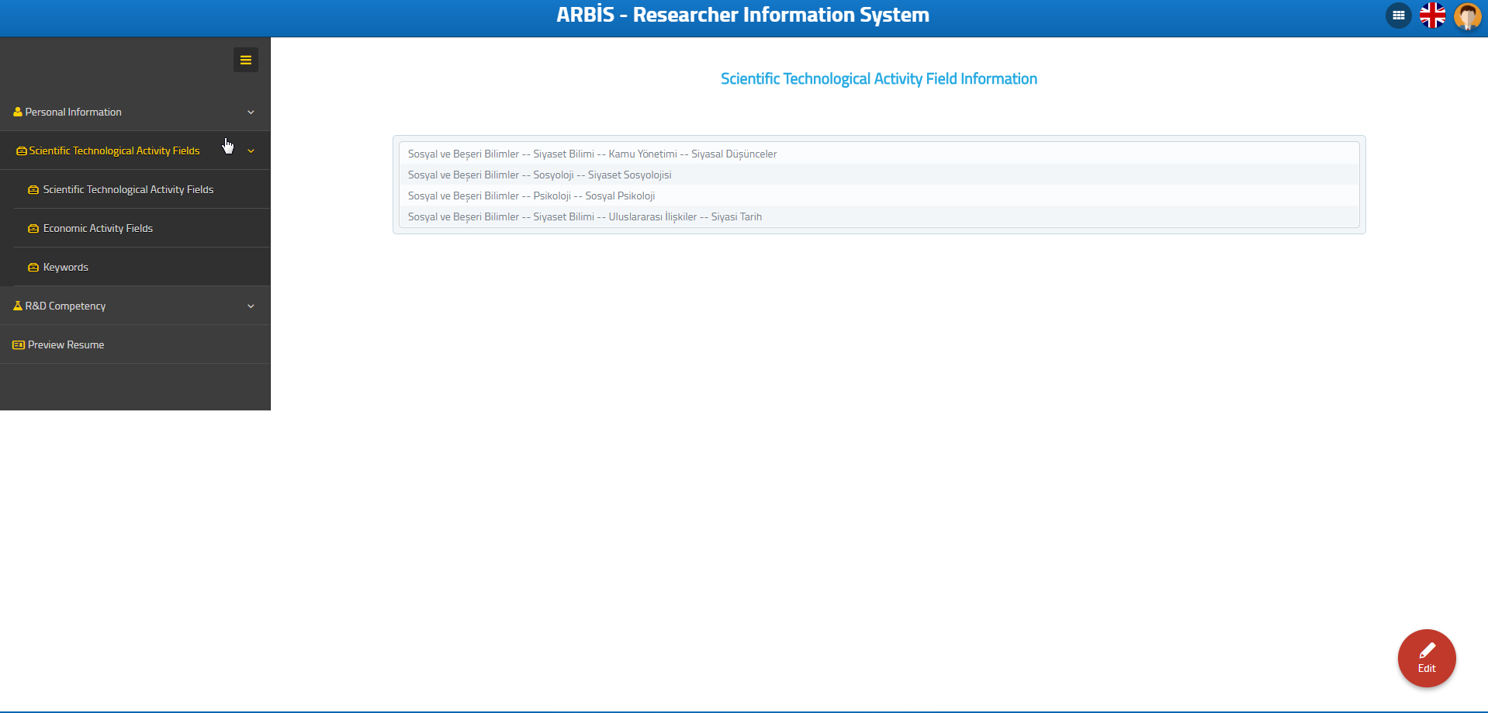
Please feel free to insert your personnel and educational information to form your CV. Your CV will need to be up to date in the application process.
Step 2: Loging in to Joint Application System:
Please enter http://uidb-pbs.tubitak.gov.tr/ in order to reach the Application system. The necessary steps are given below.
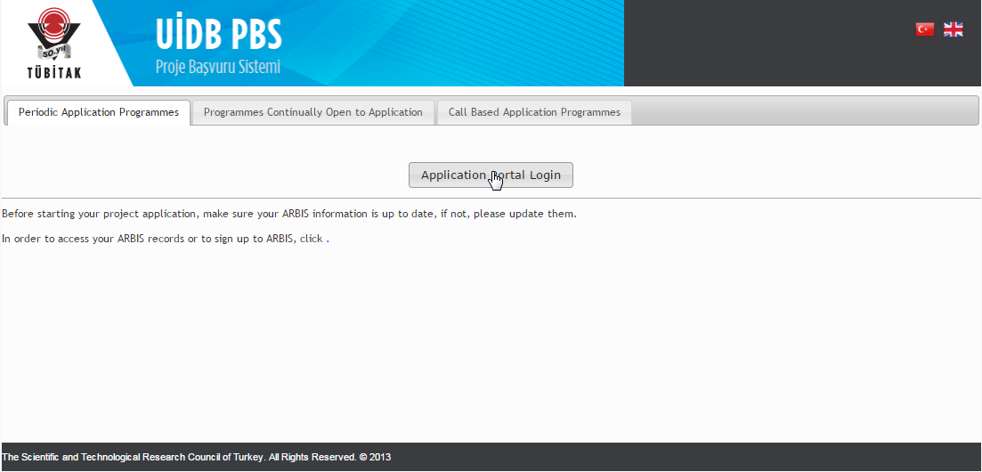
After entering uidb-pbs.tubitak.gov.tr please click on “Application Portal Login” on the welcome page.
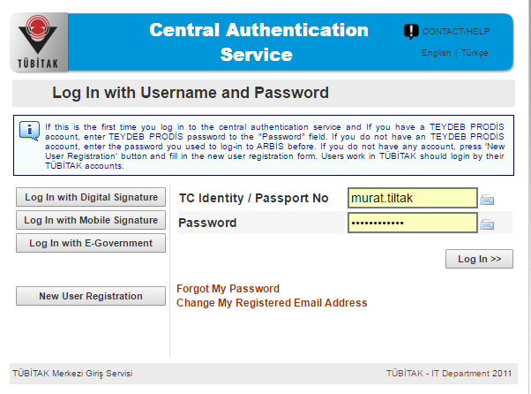
You may log in with your ARBIS username/Passport No and password to the Application System.
Note: Until this point, each step was universally needed both by Counterpart Coordinator and Counterpart Institution Expert.
From this point on the tutorial will go on role by role due to their different authorizations.

FOR COUNTERPART COORDINATORS (Joint Application System):
Editing the Application:
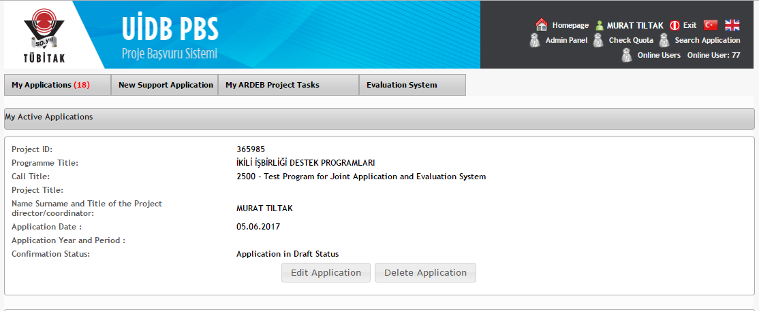
After logging in to the Joint Application System please click on “Edit Application” button to enter the application page.
The application page is constituted of all the necessary steps (listed on the left side of the page) to complete the application process. Both Turkish and Counterpart Coordinators are able to make any changes in any step.

Further details about each step are as follows:
1. Application Description: The introduction page of the call. All the necessary information about the call is given in this step.
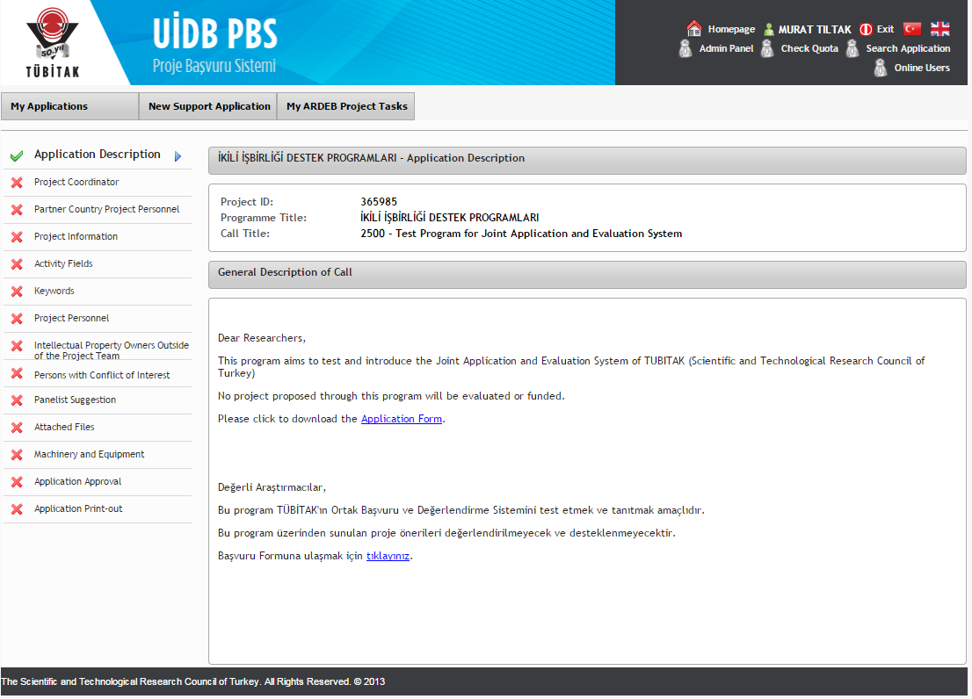

2. Project Coordinator: This page includes the details about the Turkish Coordinator and needs to be filled by them. Some of the information is also automatically filled by the system itself from the ARBIS information of the Coordinator.
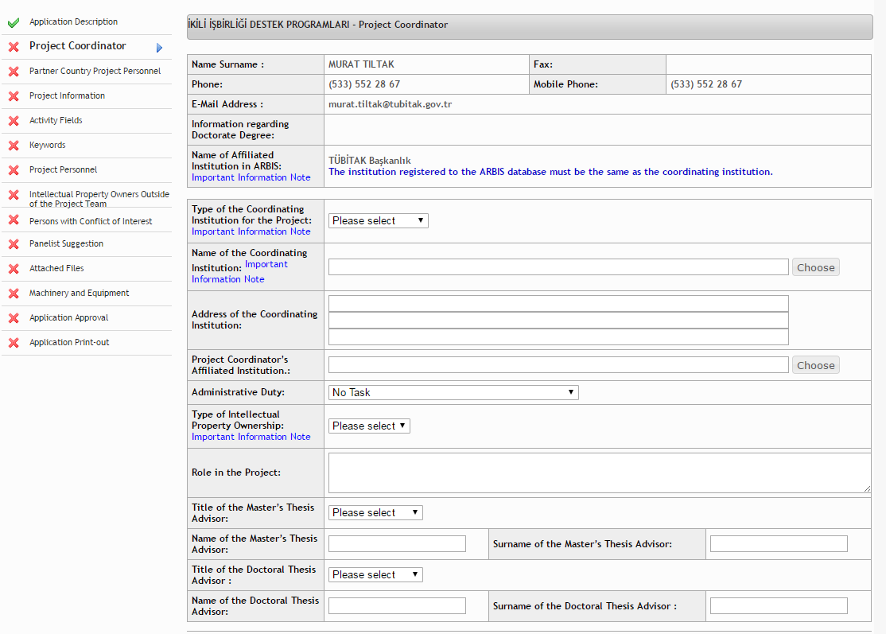

3. Partner Country Project Personnel: This step is to add the Counterpart Coordinator by the Turkish Coordinator. Counterpart Coordinator should have resgistered to ARBIS for Turkish Coordinator to add them. Once they are added, they will be able to log in and make any changes in the Application.
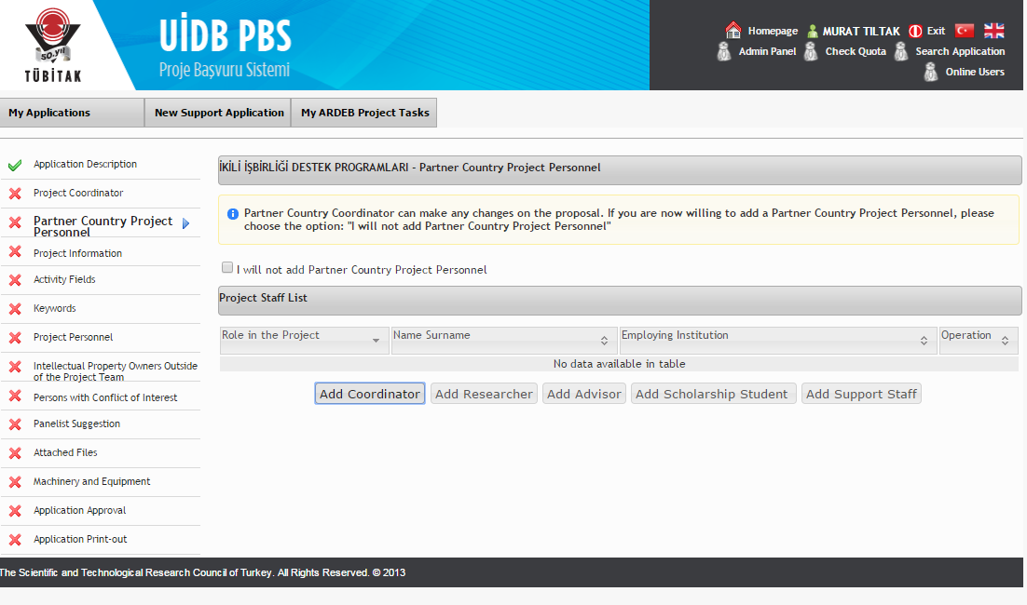
“Add Partner Country Coordinator” Screen:
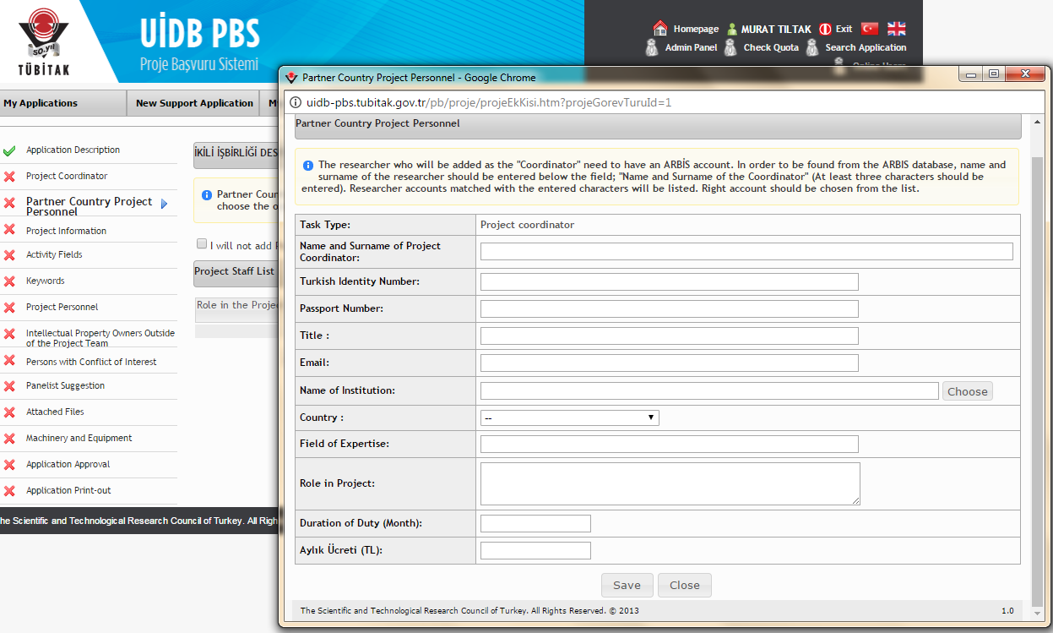
4. Project Information Step: This step includes short details about the proposal such as the title, abstract, research type, research field.
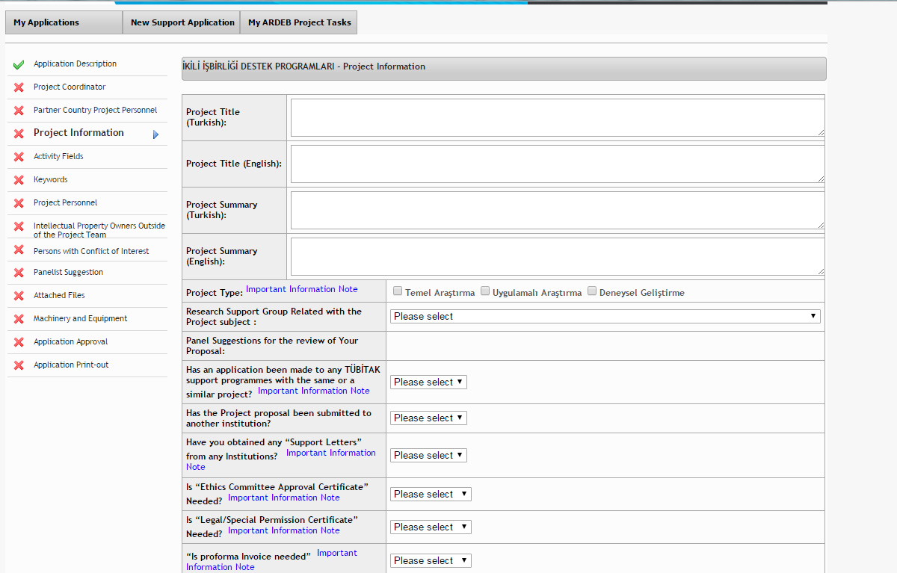

5. Activity Fields:
This step is to give more details about the activity field(s) which is/are most fitting with the proposal. (Ex. “Social and Human Sciences --> Political Science”, “Technical Sciences --> Geological Engineering --> Mineral Deposits-Geochemistry --> Energy Resources”)
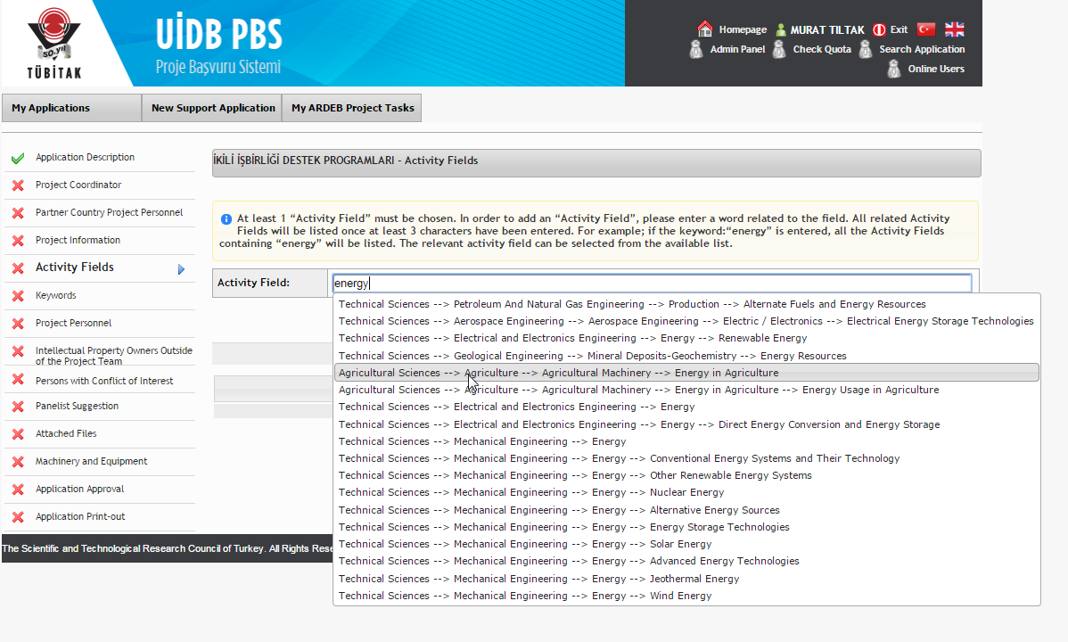

6. Keywords: In this step, the coordinators are asked to insert both Turkish and English keywords which are necessary for the classification of the pro.posal.
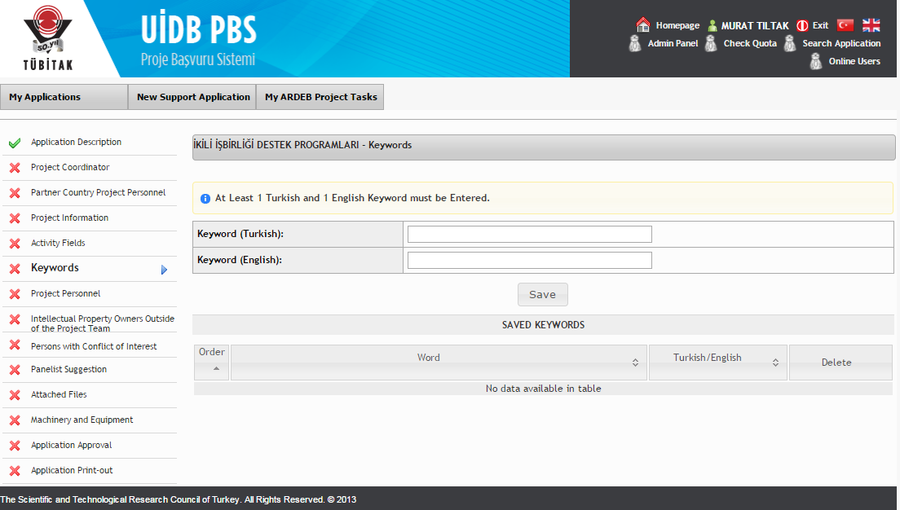

7. Project Personnel: This step includes the information for Turkish research group which needs to be filled by the Turkish Coordinator.
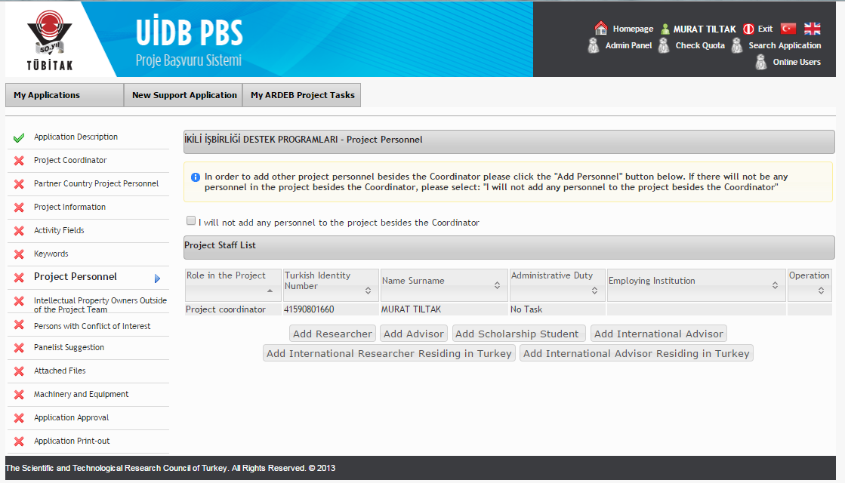

8. Intellectual Propery Owners Outside of the Project Team: Those who have contributed to the proposal during the preparation process but are not in the project team should be indicated as a “right owner” in this step to avoid intellectual property right violations.
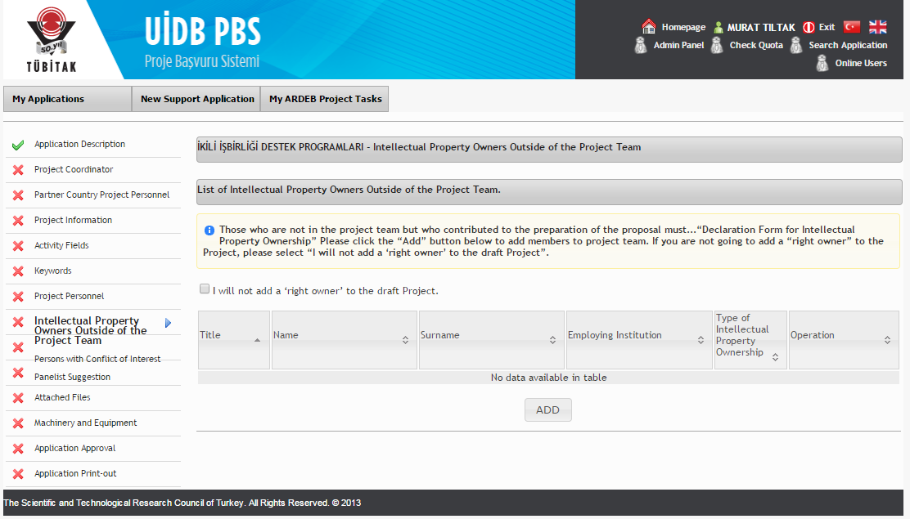

9. Persons with Conflict of Interest: This step has to be filled by the Turkish Coordinator to indicate the persons with conflict of interest. This step will be necessary for the nomination of suitable reviewers.
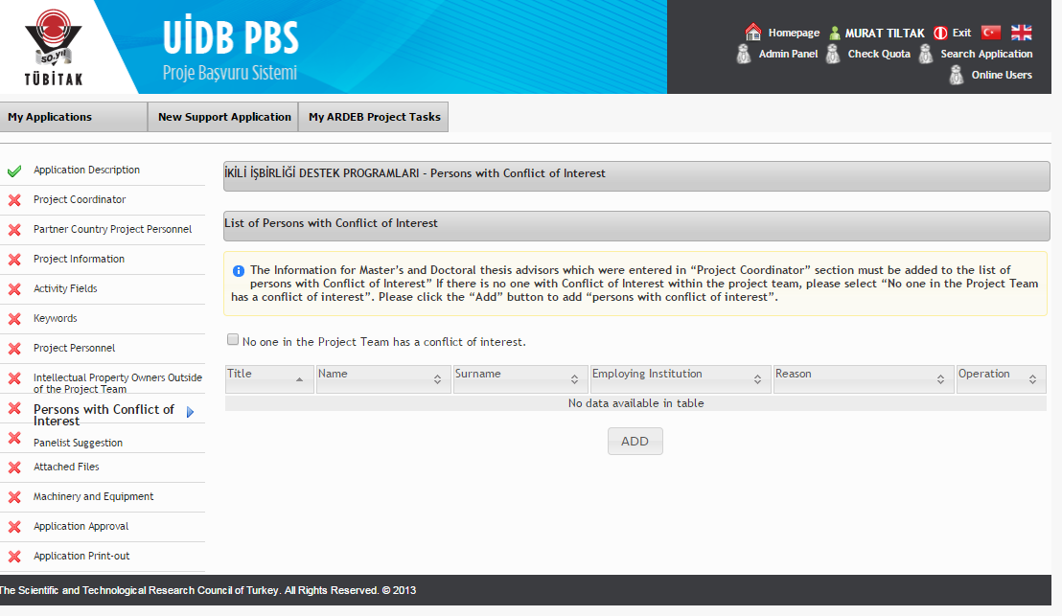

10. Panelist Suggestions: In this step, maximum 4 reviewer suggestions can be indicated by the coordinators. Besides, during the evaluation process TUBITAK will be inviting both Turkish and Foreign reviewers to review panels in consultation with the Counterpart Institution Expert.
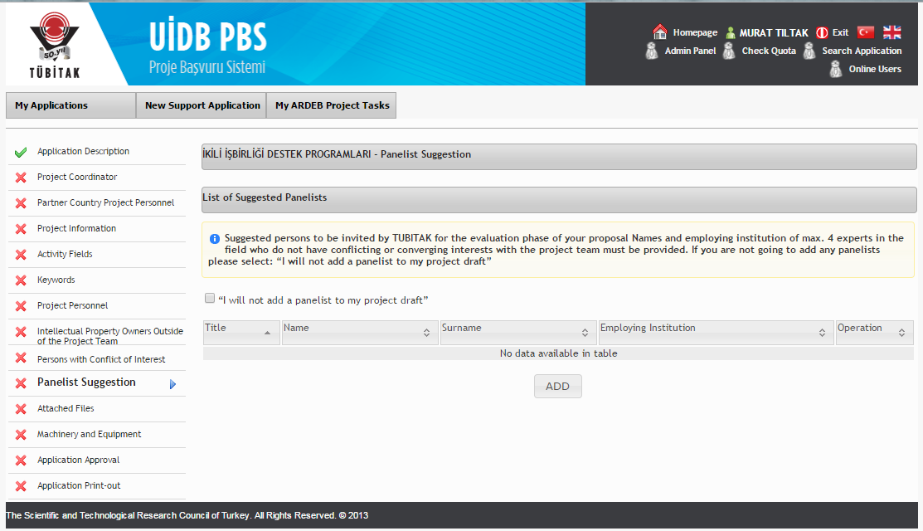

11. Attached Files: One of the most important steps, “Attached Files”, contains all the necessary documents that will be filled and uploaded by coordinators to be used in the review process. Documents including Proposal Form, Budget Form, Required Equipment Form, Bibliography Form has to be uploaded during the applcat
ion process. In consultation with partner country institution, TUBITAK can design and change documents according to the program and call.
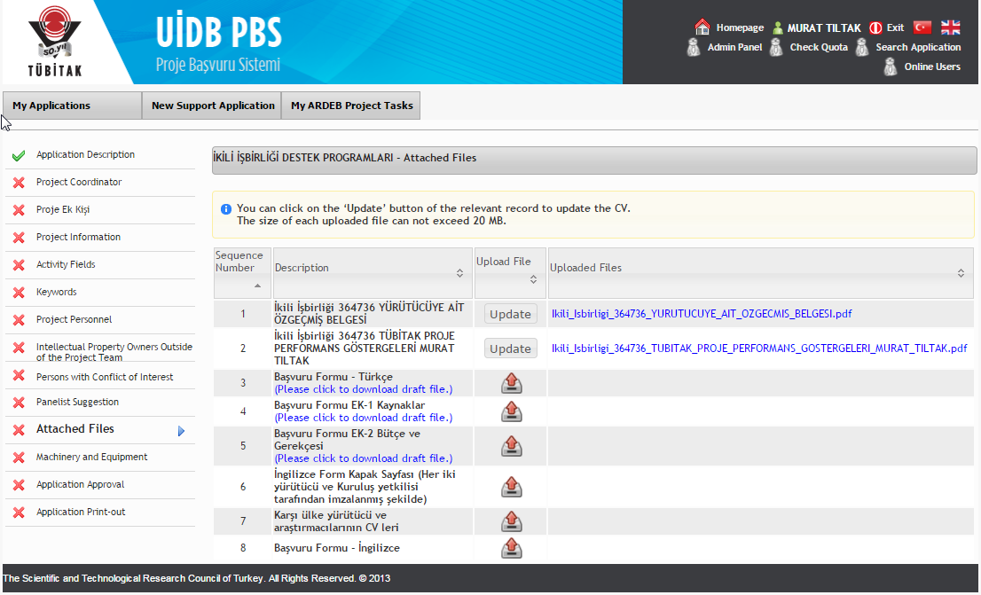

12. Machinery and Equipment: This step has to be filled by the Turkish Coordinator to indicate details about the necessary equipment that will be used by the Turkish Project Group. Information about the Counterpart Project Group’s equipment requirements will be filled in the Required Equipment and Budget forms.
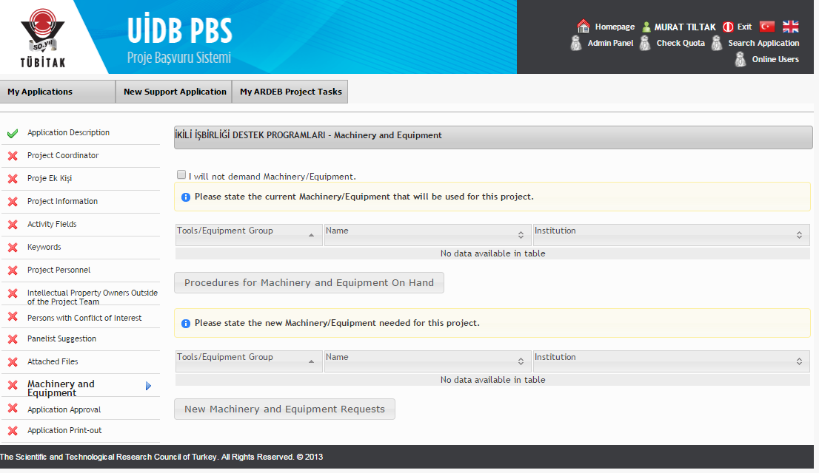

13. Application Approval: Last step to complete the application. By clicking on “Confirm Application” the coordinators confirm that their proposal is ready to be reviewed. During the call period, until the deadline, Both Turkish and Counterpart Coordinators can confirm, cancel confirmation, make any changes and confirm again.
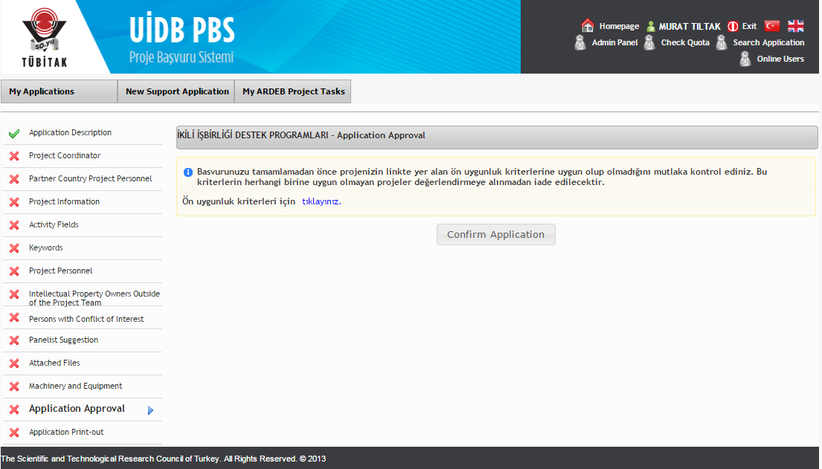

12. Application Print Out: This step includes the print out form which needs to be signed and send to TUBITAK Directorate for International Cooperation by the Turkish Coordinator.
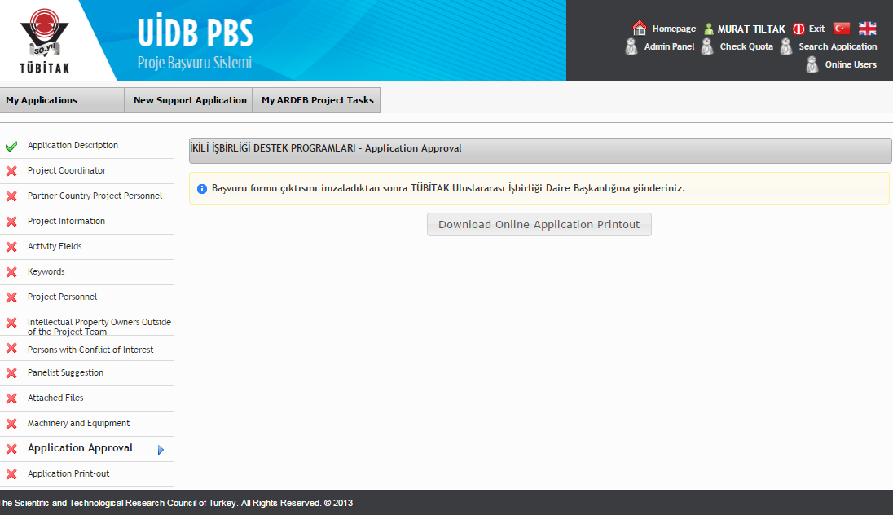

FOR COUNTERPART INSTITUTION EXPERT:

1. Addition of the Partner Country Expert:
The Counterpart Institution Expert is added to the system by TUBITAK expert. As shown below, TUBITAK expert types down the name of the Partner Country Institution Expert (let’s say it is Mona Sax) in the related field. The system brings the name of the Expert if they have registered in ARBIS.
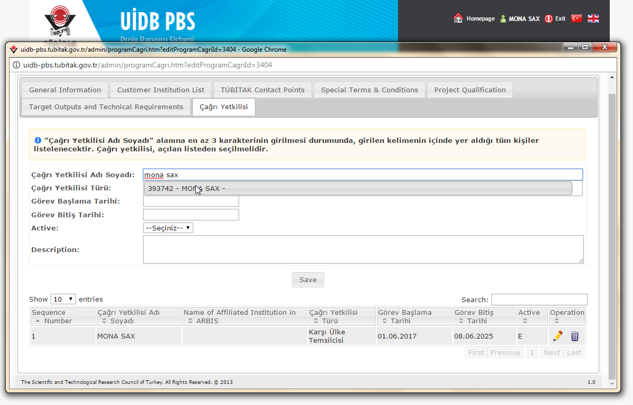

2. Loging in the System: Enter “uidb-pbs.tubitak.gov.tr”.
Once they are added by TUBITAK Expert, Partner Country Experts are able to log in to the system with their ARBIS username and password.

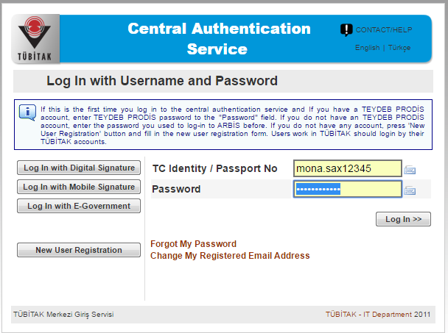

3. Finding the Applications: After logging in the system the page below will appear to the Partner Country Institution Expert. First click on
button.
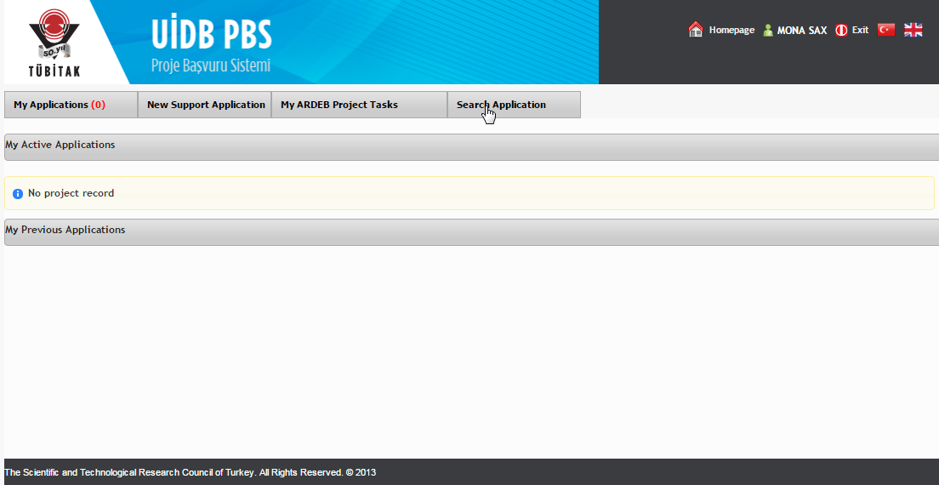

The Search Engine: The Counterpart Institution Expert is able to see all the submitted applications through using the search engine. With the help of search engine, they can enlist all the applications and download all the uploaded documents of each proposal.
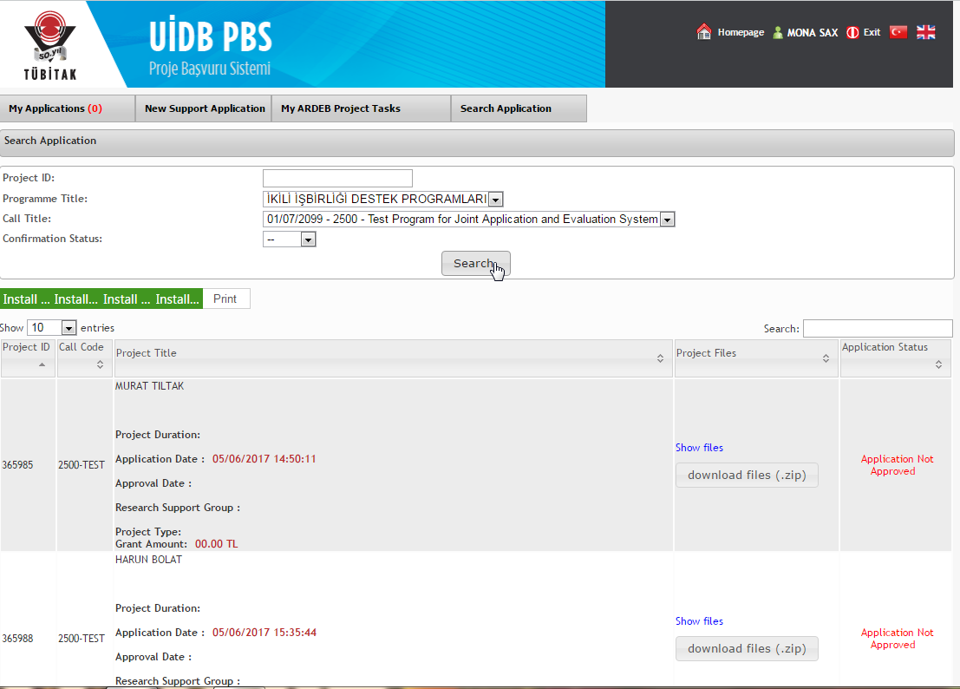

-End of the Tutorial-

Thank you very much for your attention. If you have any questions about the system. Please feel free to send your message to uidb@tubitak.gov.tr We will be pleased to assist you in any stage.

